T&C SMASH BURGER 20
Kilcoyne Farm beef, shredded romaine, cheddar, signature sauce, brioche, pickles (G,D,E)
Add another smash patty +5

T&C SEASONAL SMASH BURGER 20
Kilcoyne Farm beef, mushrooms, swiss cheese, caramelized onion, brioche (G,D,E)
Add another smash patty +5

SLICED SIRLOIN DIP 23
Kilcoyne Farm sirloin, beef au jus, caramelized onions,
grilled focaccia, swiss cheese, seasonal giardiniera (G,D)

FRIED CHICKEN PARM SANDWICH 20
breaded chicken breast, red sauce, burrata, grilled focaccia (G,E,D)

Substitute Gluten Free Bread or Bun +2
All sandwiches come with a side of lettuces or upgrade to fries +5
BORSCHT 18
veal stock, beets, crème fraiche (D)

FIELD GREEN LETTUCES HALF 7 / FULL 12
herbs, red wine vinaigrette (VG)

BEET SALAD 20
field green lettuces, roasted beet, candied hazelnut, pickled apples, feta cheese, apple bacon vinaigrette
(D,E)

CAESAR SALAD HALF 9 / FULL 13
romaine, white anchovy, classic dressing,
garlic croutons, farm parm (G,D,E)

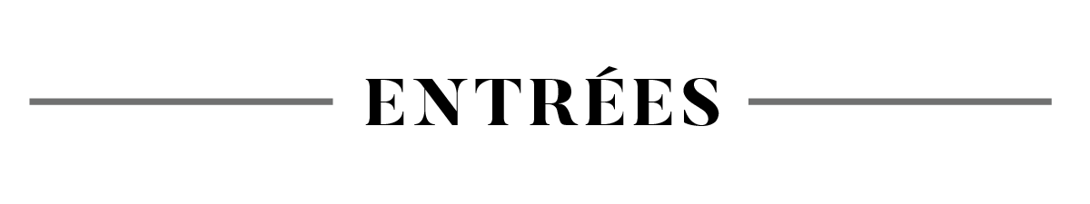

HOUSE BAKED FOCACCIA 2 / person
whipped maple butter (G,V)
Gluten Free Bread available +2

LOCAL GRAZING BOARD 29
curated assortment of NYS cheese, cured meat & charcuterie, accompaniment, griddled bread, cracker (G,D)

FRIED MEATBALLS 12
red sauce (G,D,E)

FRIED CHEESE CURDS 12
aioli (D,E,V)

BOWL OF FRIES 9
T&C seasoned salt, aioli, ketchup (E,V)

SHRIMP COCKTAIL 18
traditional cocktail sauce, remoulade sauce (E)

OUR EAST UTICA GREENS 18
escarole, cherry peppers, bacon, pecorino, oreganata, garlic cream sauce (D,G)

SMOKED STEELHEAD TROUT DIP 14
cornichons, grilled bread (D)

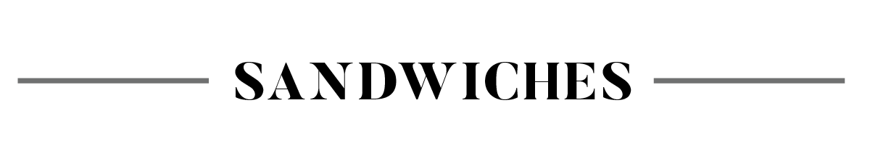
(5) SHRIMP 16 • SCALLOPS 5/EACH • CHICKEN BREAST 12
STEELHEAD TROUT 19 • BURRATA 10 • GOAT CHEESE 5
BACON 3 • SUNNY EGG 3 • MASHED POTATO 6 • ROASTED VEG 6
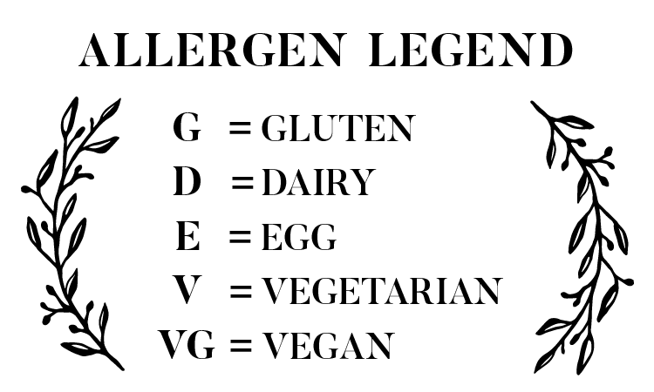
PAN SEARED SCALLOPS 36
butternut squash risotto, herb gremolata, chevre (D)

SEASONAL RISOTTO 29
butternut squash, sage, chevre (D)
Vegan preperation avilable upon request

PAN ROASTED STEELHEAD TROUT 32
Smoked pork broth, chic peas, spinach & onion

OUR CHICKEN RIGGIES 26
house made rigatoni, bell & cherry peppers, mushrooms, onions, chicken thigh, riggie sauce (G,D,E)
Substitute Gluten Free Pasta +3
Substitute Shrimp + 8
Substitute Steak + 10

BRISKET MACARONI & CHEESE 34
house made elbow macaroni, NYS three cheese sauce, house made BBQ, scallion (G,D,E)

BRAISED VEAL MARSALA 37
house made casarecce pasta, mushroom, creme fraiche, herb gremolata (G,D,E)

NOT YOUR GRANDMOTHER'S MEATLOAF 28
mashed potatoes, seasonal vegetables, ketchup gravy (D)

COCONUT CHIPOTLE BRAISED PORK 28
polenta, roasted vegetables, herb gremolata (D)

STEAK & POTATOES 41
NY strip, seasonal vegetables, mashed potatoes, red wine demi (D)
Add Shrimp + 16
Add Scallops +5/each

Chef – Jimmy Feliciano
Chef - Howard Shanley

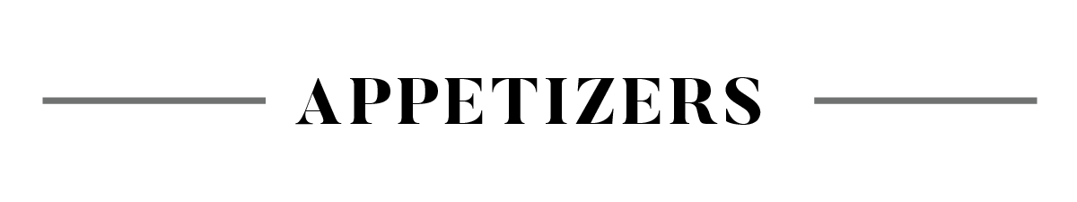

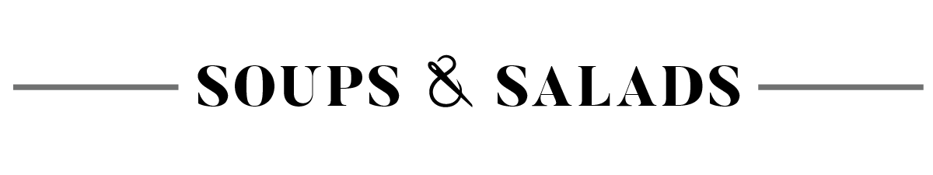

From New York’s farms to your table, and everything in between-- quality, care and authenticity in every step

SIGNATURE COCKTAILS

OVER THE RIVER 17
Albany Vodka, Aperol, Chai Syrup, Cranberry, Lemon Juice, Whites

DUCK A L’ORANGE 18
Duck Fat Washed Bourbon, Orange Bitters, Orange Liqueur

BORROWED THYME 16
Albany Vodka, Barrows Intense Ginger Liqueur, Lemon Juice, Honey, Thyme

THROUGH THE WOODS 17
Rittenhouse Rye, Crème De Banana, Maple Syrup, Black Walnut Bitters

GRANDMOTHER’S HOUSE (our take on a hot toddy) 17
Mezcal, Captain Morgan, Lemon Juice, Honey, Smoke

UTICA COFFEE COCKTAILS

SEASONAL ESPRESSO MARTINI 17
Pumpkin Syrup, Espresso, Vodka, Coffee Liquor, Crème de Cocoa

ESPRESSO MARTINI 16
Espresso, Vodka, Coffee Liquor, Crème de Cocoa

OH NO YOU DIDN’T 17
Pistachio or Coconut, Espresso, Vodka, Coffee Liquor, Crème de Cocoa

CAPPUCCINO MARTINI 16
Espresso, Vodka, Coffee Liquor, Crème de Cocoa, Bourbon Cream

BUBBLES
LAKEWOOD, BUBBLY CANDEO Finger Lakes 10
PRIMA PERLA, PROSECCO Italy, Veneto 12

SOUTH HILL

WHITES
HERMANN J. WIEMER, RIESLING Finger Lakes 13
BEDELL CELLARS, PINOT GRIS Long Island, North Fork 12
LAMOREAUX LANDING, UNOAKED CHARDONNAY, Finger Lakes 12
HECTOR WINE CO., SAUVIGNON BLANC Finger Lakes 12
POPPY CHARDONNAY, California, Santa Lucia Highlands 15

ROSE

RIA’s WINES DRY ROSE, Finger Lakes 13

REDS

BOUNDARY BREAKS, CABERNET FRANC Finger Lakes 13
BORELL-DIEHL, PINOT NOIR Germany, Pfalz 13
LA BETE NOIRE, MALBEC France, Cahors 13
HECTOR WINE CO., CABERNET & SYRAH BLEND Finger Lakes 13
FREELANDER, CABERNET SAUVIGNON California 14
CANTINE DEI, ROSSO DI MONTEPULCIANO Italy, Tuscany 14
LA JASSINE, GRENACHE & SYRAH France, COTES-DU-RHONE 14

PACKAGE BEER
TAILORED CLASSICS

NEW YORK SOUR 16
Four Roses Bourbon, Sour Mix, Whites, Simple, Red Wine

PURPLE PLANE 16
Emperess Gin, Elderflower, Violet Liqueur, Pear

BEE’S KNEES 16
Barr Hill Gin, Lemon Juice, Honey

BOURBON, RYE, OR IRISH WHISKEY FLIGHTS AVAILABLE 35
ASK YOUR SERVER WHAT THE SELECTIONS ARE

NA COCKTAILS

TELEPATHY CLUB (NA) 8
Pear, Fresh Herbs, Lime, Tonic

SPARKLING CHERRY LIMEADE (NA) 10
Luxardo Cherry Syrup, Lime Juice. Soda Water

EARLY FROST (LOW ABV or NA) 12 / 10
Coffee Liqueur, Root beer, Sweet Cream, Chocolate & Orange Bitters

.

e, Soda Water

UTICA CLUB - PILSNER, 5% ABV | Utica 5
HEINEKEN - LAGER, 5.0% ABV | Holland 5
LABATT BLUE- LIGHT LAGER, 4.0% ABV I Canada 5
MICHELOB ULTRA - LIGHT LAGER, 4.2% ABV | Missouri 5
KIRIN ICHIBAN - MALT LAGER 5.0% | Japan 6
NARRAGANSETT - LAGER 5.0% ABV | Rhode Island 6
MODELO - LAGER 4.4% ABV I Mexico 6
STELLA ARTOIS - LAGER 5% ABV I Missouri 7
KONA BIG WAVE - GOLDEN ALE 4.4% ABV I Hawaii 6
OMMEGANG NEON RAINBOWS- NEIPA 6.7% ABV| Cooperstown 12
GROW - SEEDLING III HAZY IPA 6.0% ABV | New Hartford 12
PRISON CITY - MASS RIOT NEIPA 6.8% ABV| Auburn 12
TALKING CURSIVE - SOUR SUMMER HAZE IPA I Syracuse 12
MEIERS CREEK- OKTOBERFEST FEISTBIER 5.5% I Cazenovia 9
DUVEL - BELGIAN STRONG BLOND 8.5% ABV | Belgium 14

PHONOGRAPH, HARVEST CIDER, UN-SWEET 6.3% ABV | Ithaca 7 PHONOGRAPH, HARVEST CIDER, SEMI-SWEET 5.4% ABV | Ithaca 7
PHONOGRAPH, ROSÉ CIDER, BRUT 6.2% ABV | Ithaca 7

HIGH NOON 4.5% ABV | California 7
ASK YOUR SERVER ABOUT OUR SELECTION.

ATHLETIC BREWING CO. <.5% ABV | Connecticut 6
Upside Dawn Golden Ale - Ripe Pursuit Lemon Radler -
Run Wild IPA

Root Beer - Ginger Beer 4

CIDER
HARD SELTZER
NON ALCOHOLIC
SARANAC SOFT DRINKS

